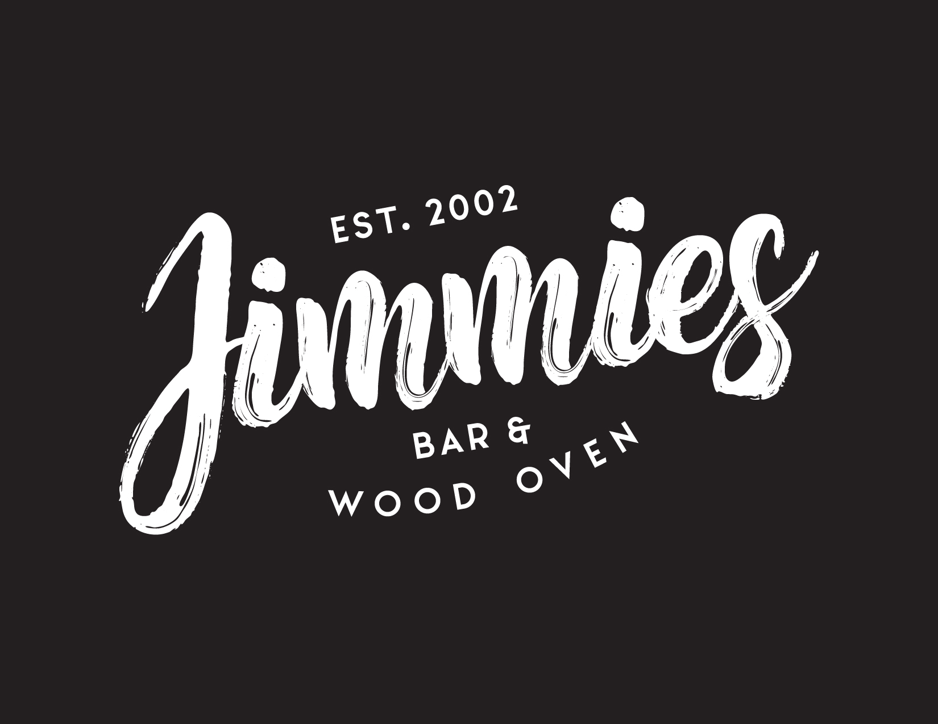

Special Occasions Catering
In-House & Off-Site
Wedding Receptions
Engagement Parties
Birthdays
Christenings
Corporate Events
6 Main Street Crafers SA

Ph: 8339 1534

www.jimmies.com.au / siennajimmiesrestaurant@gmail.com

Thank you for considering Jimmies Restaurant and Catering as the setting for your upcoming special occasion. Jimmies Restaurant and Catering is situated at the foot of Mount Lofty in the picturesque Adelaide Hills. The century old stone building has a rich local history and has been tastefully restored. Our focus is to provide superior modern cuisine tailored to suit your needs.
Jimmies Restaurant has a versatile floorplan and a beautifully manicured garden for your event. We work closely with you to create the perfect atmosphere for your occasion whether it be a relaxed, formal or intimate affair. Photos of spaces will be available on our website from April 30, 2016. Visit www.jimmies.com.au
Cocktail Events
We offer functional spaces for cocktail style events and can accommodate up to 150 guests standing inside and or 150 guests standing outside.
Formal Sit-Down Events
The restaurant seats up to 95 guests inside and there are two side rooms overlooking the garden. The garden itself can seat up to 130 guests. Our garden area looks particularly stunning when set up for any special occasion.
We welcome you to make a time to view our facilities and to discuss the details of your function and we look forward to assisting you in creating the most memorable event!
To discuss your upcoming event call Sienna, our Restaurant Manager & Functions Coordinator on 8339 1534 or email Sienna at siennajimmiesrestaurant@gmail.com
Special Note:
Jimmies Restaurant and Catering offer off-site catering for small gatherings right up to the largest wedding or event. Please email Sienna at siennajimmiesrestaurant@gmail.com with all enquiries for off-site catering.
[$1,500 Minimum Food Spend for all off-site catering]

Beverage Packages
Option 1: Standard Package
Wines: choose up to 3  Anderson Hill Sparkling Chardonnay  Riposte Stiletto Pinot Gris  Kilikanoon Skilly Pinot Gris  Riposte Foil Sauvignon Blanc  Riposte Dagger Pinot Noir  Riposte Cutlass Shiraz  Penny’s Hill Cracking Black Shiraz  Kangarilla Rd Cabernat Sauvignon | Beers: choose up to 2  Coopers Pale Ale  Adelaide Hills Apple or Pear Cider  Corona  Peroni  Soft Drinks  Selection of soft drinks and juices  Espresso Coffee & Tea Selection
2 hours: $30 per person
3 hours: $40 per person
4 hours: $50 per person
5 hours: $60 per person
Option 2: Premium Package
Wines: choose up to 3  Paul Louis Sparkling Blanc de Blanc  Deviation Road NV Altair Sparkling Rose  Penley Estate Sparkling Pinot Noir  Skillogalee Riesling  Babich Black Label Sauvignon Blanc  Rockford Alicante Bouchet Rose  Samuel’s Gorge Shiraz  Pike & Joyce Pinot Noir | Beers: choose up to 2  Jimmies Red Ale  Crown Lager  Cascade Premium Light  Adelaide Hills Apple Cider  Vale Lager  Soft Drinks:  Capi Sparkling Mineral Water  Selection of soft drinks and juices  Espresso Coffee and Tea Selection
2 hours: $50 per person
3 hours: $60 per person
4 hours: $70 per person
5 hours: $80 per person
Option 3: Premium Pre-Dinner Drinks Package
Sparkling Wine: choose 1  Veuve Clicquot Champagne  Moët and Chandon Champagne | Beers: choose 1  Lobethal Bierhaus Indian Pale Ale  Lobethal Bierhaus Chocolate Stout  Jimmies Red Ale  James Boags Premium  Soft Drinks  Capi Sparkling Mineral Water  Selection of soft drinks and juices  Espresso Coffee & Tea Selection
1 hour: $80 per person
Option 4: On Consumption
Choose from Jimmies Restaurant and Catering’s Beverage List
Corkage: Bottles of wine may be brought into the restaurant for a charge of $20 per bottle.
(Beer & Spirits may be included subject to negotiation)

Jimmies Restaurant and Catering choose to work with and recommends the following businesses
to help you create your special occasion:
Australian Hiring Company
Set Your Scene Wedding Décor Hire
EasyAV- Event Audio, Lighting and Vision
Ivy Shed- Florist

Food Packages
Option 1:
Standard Cocktail Package
Choose 6 canapes: up to 2 hours $40 per person - 9 pieces per guest
Choose 8 canapes: up to 2 hours $50 per person – 12 pieces per guest
(The above Cocktail packages are not designed for full meals)
Premium Cocktail Package
Choose 12 canapes for up to 3 hours $75 per person – 16 pieces per guest
Canape Menu
Rare roast beef, sough dough wafers, olive tapenade
Smoked salmon crostini, crème fraiche, capers, cucumber, horseradish
Natural oysters, jalapeno nam jim
Warm goats curd tartlets, asparagus, truffled honey
Mushroom croquettes, pecorino, truffle mayonnaise
Seared scallops, cauliflower, blue cheese, brioche crumbs
Peking duck crepes, hoisin, cucumber
Fish goujons, house tartare
Panko crumbed prawn skewers, saffron aioli
Duck pate, sour dough wafers, chives
Lamb pinchos, cumin yoghurt
Chicken and leek pie, kasundi
Prawn or vegetable gyoza, ginger soy
Lamb and feta meatballs
Polenta fries, salsa verde
Option 2: Rustic Feast 2 choices $45 3 choices $50
All meals are placed down the centre of tables for guests to share
Baked barramundi fillets, coconut chermoula
Chicken tagine, labne, roast capsicum, almond, coriander
Chargrilled mojo chicken breast, fresh coriander, sour cream, lime
Triple cooked pork belly, Vietnamese salad
Pulled pork, apple slaw, guacamole, sour cream
Zucchini fritters, grilled haloumi, mint, cherry tomato, pomegranate molasses
8 hour barbecue braised beef ribs
Slow cooked duck legs, green peas, thyme
*All served with Cuban rice or roasted potatoes and green leaves
Option 3: Sit Down Set Menu
2 Courses $55 per person (Entrée & Main or Main & Dessert)
(Alternate drop $50 per person)
3 Courses $70 per person (Entrée Main & Dessert)
(Alternate drop $65 per person)
Entrées: Choose 1 (additional choices $5 per choice per person)
Beef carpaccio, tomato, shaved pecorino, truffle oil, balsamic glaze
King fish ceviche, avocado, lime, orange (add $6 per person)
Blue swimmer crab raviolo, tomato fennel butter (add $6 per person)
Triple cooked pork belly, kimchi, pork crackling, honey, kewpie mayo
Roasted cauliflower soup, confit truffled mushrooms
Charred quail, haloumi, rocket, walnuts, mint, pomegranate dressing
Chicken and shitake mushroom, san choy bau
Salt and pepper soft shell crab, asian herb salad, roasted chilli lime dressing
Mains: Choose 2 (additional choices $10 per choice per person)
300g Banksia MSA scotch fillet, sweet potato chips, wild mushroom whisky sauce
Tomato olive braised lamb shank, lemon olive oil crushed potato, gremolata
Atlantic salmon fillet, chilli, garlic green beans, kipfler potato, salsa verde
Honey glazed duck leg, orange, fennel, pickled cucumber salad
Pork scotch fillet, potato galette, balsamic apples, fried sage
Chimichurri chicken breast, parmesan potatoes, cuban salsa, charred lime
Eggplant parmigiana, basil, mozzarella, tomato
Gnocchi, tomato sugo, basil, pecorino

Desserts: Choose 1 (additional choices $10 per choice per person)
Chocolate macadamia pudding, hot chocolate sauce, vanilla bean ice cream
Honey almond ice cream torte, crunchy almond pistachio praline
Chocolate salted caramel tart, buttery caramel popcorn, house vanilla bean ice cream
Moscato poached pears, double cream, honey roasted walnuts
Fresh berry tart, meringue, vanilla bean ice cream
Bread and butter pudding, caramelised banana, honeycomb ice cream
Nutella oreo cheesecake, hazelnut crumble, mascarpone, strawberry, mint
Trio of gelati – choose 3 from the following flavors:
Salted caramel | Blood Orange | Toffee | Chocolate | Mango sorbet | Lemon sorbet |Cookies and cream | Vanilla bean

Option 4: Off-Site Seafood Paella – cooked and served on display
$40 per person
Traditional paella with calaspara rice, prawns, mussels, spicy chorizo sausage, infused with saffron threads and smoked paprika. (*Vegetarian option available).
$45 per person – Include a selection of entrées
Includes a selection of our entrées from the list below.

OPTIONAL EXTRAS
Birthday Cakes $10 per person
Birthday cakes available on request. Please order one week in advance. Birthday cakes are presented, then cut by our chef and served as dessert with cream or ice-cream.
Choose:
Sticky banana and walnut pudding served hot with butterscotch sauce or
Chocolate and macadamia nut pudding served hot with chocolate fudge sauce

Option 5: Paella Parties – cooked and served on display
$35 per person
Traditional paella with calaspara rice, prawns, mussels, spicy chorizo sausage, infused with saffron threads and smoked paprika. (*Vegetarian option available). Includes rocket, pear, walnut & pecorino salad with white balsamic reduction.
$40 per person – Include a selection of entrées
Includes a selection of our entrées from the list below

OPTIONAL EXTRAS
Add Dessert and Coffee
$12 per person for a choice of one dessert served with coffee
(must be pre-ordered with your function: ask for our dessert menu)
$14 per person for a choice of two desserts served with coffee
(must be pre-ordered with your function: ask for our dessert menu)

Birthday Cakes $10 per person
Birthday cakes available on request. Please order one week in advance. Birthday cakes are presented, then cut by our chef and served as dessert with cream or ice-cream.
Choose:
Sticky banana and walnut pudding served hot with butterscotch sauce or
Chocolate and macadamia nut pudding served hot with chocolate fudge sauce
BYO Cakes no charge for you to cut and serve at your table or $3 per person for Chef to cut and serve with cream or ice-cream
BYO Drinks – Corkage $15 per bottle

Option 6: Off-Site Wood Oven Pizza
$35 per person (no seafood) or $43 per person (includes seafood)
Select 4 pizzas from our Pizza Menu
Additional selections $3 extra per person per selection

Option 7: All You Can Eat Pizza Deals
All You Can Eat Pizza & Salad (8 people or more)
$28 per person Children $14 (12 & under)
Enjoy a variety of pizzas from our pizza menu. Includes enough salad for the whole table: Rocket, pear, walnut & pecorino with white balsamic reduction
(Seafood $5 extra per person)

All You Can Eat Pizza & Salad plus a selection of Entrees
$35 per person
Includes a selection of our entrées from the list below & pizzas from our Pizza Menu below. Includes salad for the whole table: Rocket, pear, walnut & pecorino salad with white balsamic reduction
(Seafood $5 extra per person)

Pizza Menu
Garlic Prawn: garlic, prawns, roast tomato, caramelised onion, fresh rocket
Seafood and Prosciutto: prawns, scallops, prosciutto, chilli, basil salsa
Seafood: oysters in shell, prawns, scallops, fresh tomato, parsley
Moroccan Chicken: marinated chicken, roast tomatoes, roasted eggplant, spiced yogurt, coriander
Turkish Lamb: slow braised lamb, fresh tomato, mint & preserved lemon yogurt
Prosciutto: thinly sliced prosciutto, goats curd, caramelised onion, fresh tomato, basil salsa
Roasted Vegetable: wood oven roasted vegetables, goats curd, oregano salsa
Pumpkin and Zaatar: spinach, pumpkin, mushroom, zaatar, topped with danish feta, fresh rocket
Maria’s Margherita: fresh tomato, fior de latte, extra virgin olive oil, basil salsa
Mushroom Pesto & Potato: mushroom pesto, roasted potato, pecorino, truffle oil, rocket, sticky balsamic glaze
Little Pig Little Pig: pulled pork, crispy bacon, crackling, spicy kasundi base, spring onion,
pickled cucumber, bbq sauce
Pepperoni: pepperoni, caramelised onion, mushroom, olives, chilli, oregano salsa
Leg Ham and Pineapple
Cheese and Tomato: rich tomato sauce, mozzarella

Entrées
Crab, Salmon & Ginger Spring Rolls, Tomato Chilli Jam
Hummus, Slow Cooked Lamb, Fresh Herbs, Pomegranate, Fried Nuts, Wood Oven Pita
Jalapeno Popcorn Chicken, House Aioli
[Like it hot? Ask for our hot & spicy sauce! 3]
Mushroom Croquettes, Pecorino, Truffle Mayo
Duck Pate, Chunky Apple Relish, Sour Gherkins, Wood Oven Pita [GF on request]

Optional extras available for all packages:
Start with Canapes $15 per person for 3 items from list above
Shared Sides and Salads $6 per person for a selection of 2
Shared Desserts $12 per person for selection of 3
Cheese board $8 per person 3 varieties served with quince paste and crackers
Dessert Pizza (available with Pizza Option only) $8 per person for 2 choices

Sides Choices
Honey Roasted Heirloom Carrots, Cranberries, Black Sesame, Whipped Feta
Charred Zucchini, Lemon, Garlic, Mint, Labne
Rocket, Pear, Walnut Salad, Pecorino, White Balsamic
Green Leaves, French Shallots, Red Wine Vinegar, EVO
Real Potato Chips, Kassundi, Lime Aioli
Sweet Potato Fries, Lime Aioli
Dessert Choices
Toffee Apple Pizza, Salted Caramel Ice Cream
Cinnamon Sugar Beignets, Hot Chocolate Sauce, Raspberry Cream
Honeycomb Crème Brulee, Shortbread Almond Biscuit
Honey Almond Ice Cream Torte, Crunchy Almond & Pistachio Praline
Chocolate Macadamia Pudding, Hot Chocolate Sauce, Vanilla Bean Ice Cream

